Nov 2019 OSS Meeting Tulsa – Speaker: Mani Montazemi
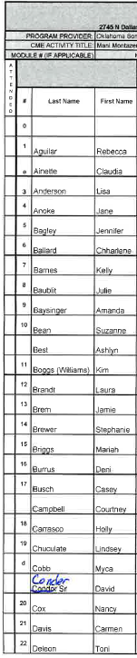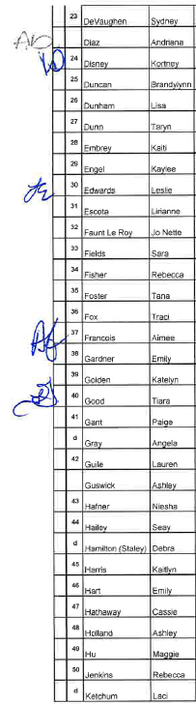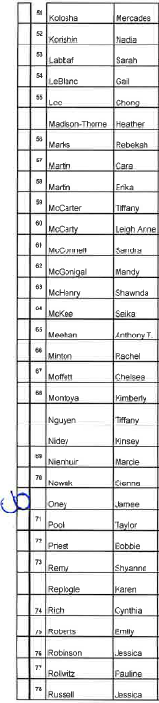
Attended: Ashlyn Best and David Conder
They signed in on the incorrect space.
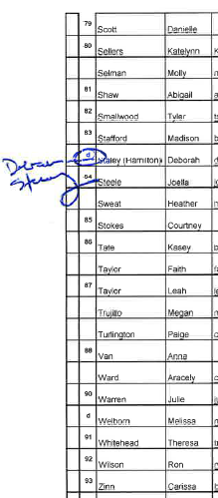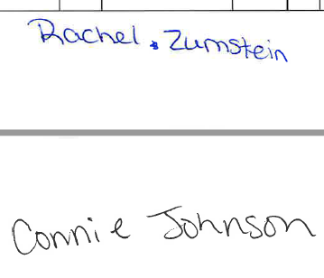

Attended: Heather Sweat, Faith Taylor, Leah Taylor (?), and Melissa Welborn
They signed in on the incorrect space.

