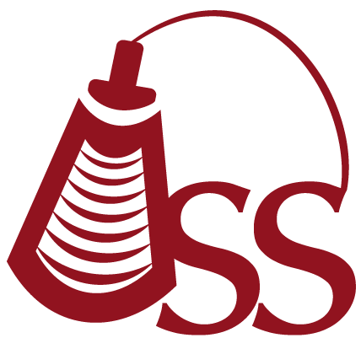

Oklahoma Sonography Society
Cordially invites you to attend a discussion on:

High Risk OB Interesting Cases
Presented by:

Casey Busch

Tuesday May 14th 2019
5:45 pm - Registration
6:15 pm - Announcements
6:30 pm - Speaker

2 CME

Tulsa Community College
10800 North, 140th East Ave Owasso, OK
Room 2321, 2nd floor

Annual OSS Membership Dues:
Tulsa Sonographer Annual Dues - $25
Tulsa Student Annual Dues - None

To make a reservation, please RSVP on Facebook:
https://www.facebook.com/groups/200192573718950/permalink/519289978475873/
Or email: oksonographysociety@gmail.com
Or visit the website: http://oklahomasonographysociety.org

