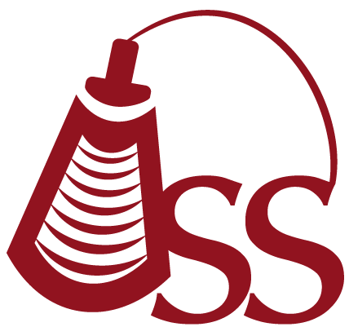

Oklahoma Sonography Society
Cordially invites you to attend a discussion on:

High Risk OB Interesting Cases
Presented by:

Casey Busch

Tuesday May 14th 2019
5:45 pm - Registration
6:15 pm - Announcements
6:30 pm - Speaker

2 CME

College of Allied Health
OU Health Sciences Center
1200 N. Stonewall
Room AHB 1047
(Enter SE back door, Everett and 8th)
Oklahoma City, OK 73117

Annual OSS Membership Dues
Sonographer $35
Student $10

To make a reservation, please RSVP on Facebook:
https://www.facebook.com/groups/200192573718950/permalink/519289355142602/
Or email: oksonographysociety@gmail.com
Or visit the website: http://oklahomasonographysociety.org

