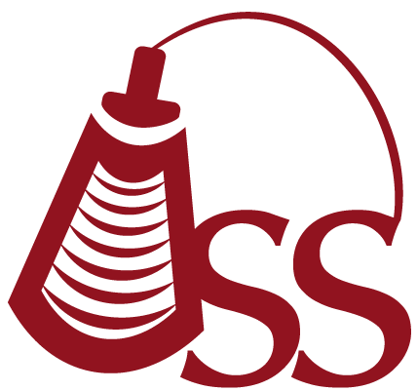

Oklahoma Sonography Society
Cordially invites you to attend a discussion on:

Interesting Echo Cases
Presented by:

Dr Chittur Sivaram

Tuesday February 12th 2019
5:45 pm - Registration
6:15 pm - Announcements
6:30 pm - Speaker

2 CME

Tulsa Technology Center
10800 North, 140th East Avenue, Tulsa, OK
Room 2321

Annual OSS Membership Dues:
Tulsa Sonographer Annual Dues - $25
Tulsa Student Annual Dues - None

To make a reservation, please RSVP on Facebook:
https://www.facebook.com/events/935092063360596/
Or email: oksonographysociety@gmail.com
Or visit the website: http://oklahomasonographysociety.org

