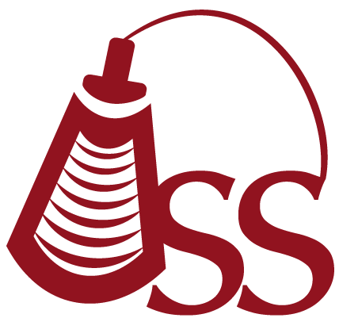

Oklahoma Sonography Society
Cordially invites you to attend a discussion on:

Mental Health
Presented by:

Jeremy Elledge, LCSW

Tuesday July 10th 2018
5:45 pm - Registration
6:15 pm - Announcements
6:30 pm - Speaker

2 CME

OU Schusterman Learning Center
4502 E 41st St, Tulsa, OK
Room 3102

Annual OSS Membership Dues:
Tulsa Sonographer Annual Dues - $25
Tulsa Student Annual Dues - None

To make a reservation, please RSVP on Facebook:
https://www.facebook.com/events/256920908303320/
Or email: oksonographysociety@gmail.com
Or visit the website: http://oklahomasonographysociety.org

