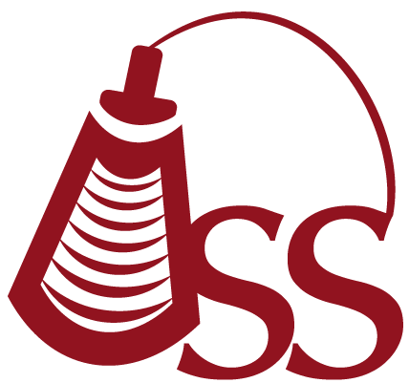

Oklahoma Sonography Society
Cordially invites you to attend a discussion on:

Mental Health
Presented by:

Jeremy Elledge, LCSW

Tuesday July 10th 2018
5:45 pm - Registration
6:15 pm - Announcements
6:30 pm - Speaker

2 CME

College of Allied Health
OU Health Sciences Center
1200 N. Stonewall
Room AHB 1047
(Enter SE back door, Everett and 8th)
Oklahoma City, OK 73117

Annual OSS Membership Dues:
Sonographer $35
Student $10

To make a reservation, please RSVP on Facebook:
https://www.facebook.com/events/316326595826885/
Or email: oksonographysociety@gmail.com
Or visit the website: http://oklahomasonographysociety.org

